### What you will need

To use the template for the dataset, click the link below and select “Use Template.”

Link to dataset: [CO2](https://docs.google.com/spreadsheets/d/1LwGHDgJkXSm8b0ziSDyC8pQGqjYVGpX9mAEVPs2KQgY/template/preview)

[](https://d3c33hcgiwev3.cloudfront.net/2_UYJGngRl21GCRp4GZdxQ_975a46684788461f8268f9758b05dbf1_CO2-Dataset.xlsx?Expires=1677542400&Signature=V2FSMi~BA9ZND0B3DoRGhQnOxt1TFS7iW5eKhqb~nEZGJKh4XEvZ2glkp5E4u~LHL~JvV5qg8s6aFnjyAjfWUWMq7asbMU05vD1X25vLn2iUIHen~JoHASplU98l7n9ACSH8VPjW1S91pfY-uhYp2hkvYpeMcxuFEaojXEtirK0_&Key-Pair-Id=APKAJLTNE6QMUY6HBC5A)

## Create a chart



1. Log in to Tableau Public. If you have not created an account yet, refer to the earlier [Reading: Logging into Tableau Public](https://www.coursera.org/learn/visualize-data/supplement/HyqLQ/logging-into-tableau-public).

* Note: Tableau frequently updates its user interface. The latest changes may not be reflected in the screenshots presented in this activity, but the principles remain the same. Adapting to changes in software updates is an essential skill for data analysts, and it’s helpful for you to practice troubleshooting. You can also reach out to your community of learners on the discussion forum for help.

2. Go to your profile. Hover over the circle in the upper-right corner and click My Profile.

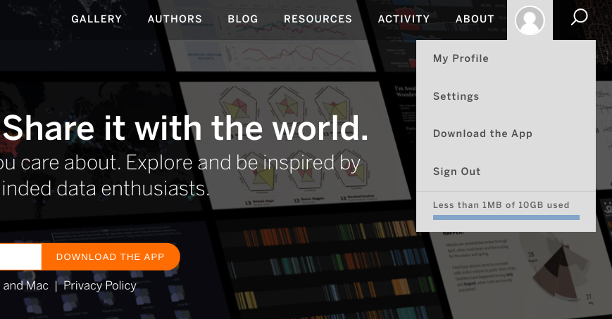

3. Under the Getting Started header, click Create a Viz.

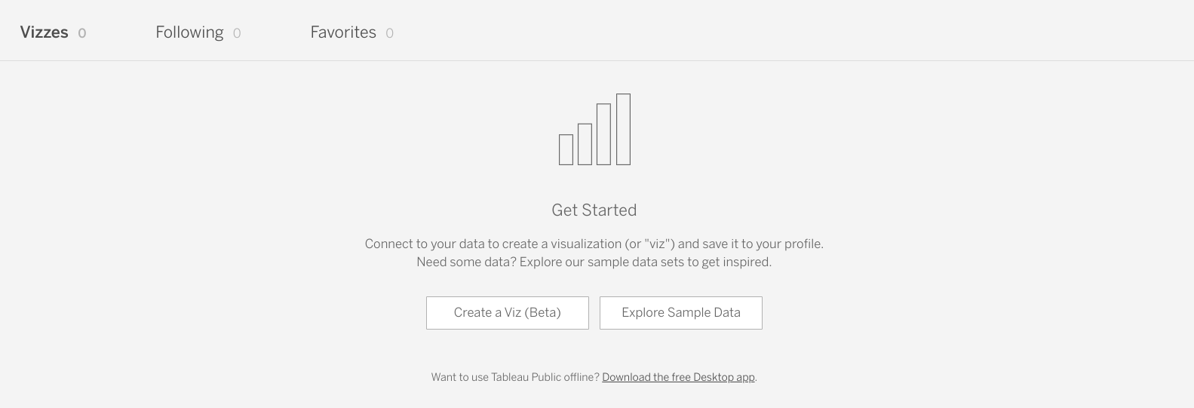

4. This may bring you to the Connect to Data window. If so, go to the Files tab and open the CO2 dataset you downloaded earlier. If not, navigate to the Data tab at the top of Tableau Public interface. Under the dropdown, click New Data Source. Then open the CO2 dataset.

5. Once you have uploaded the data, you will notice the following display. Locate the sheets contained in the data file on the left side of the screen.

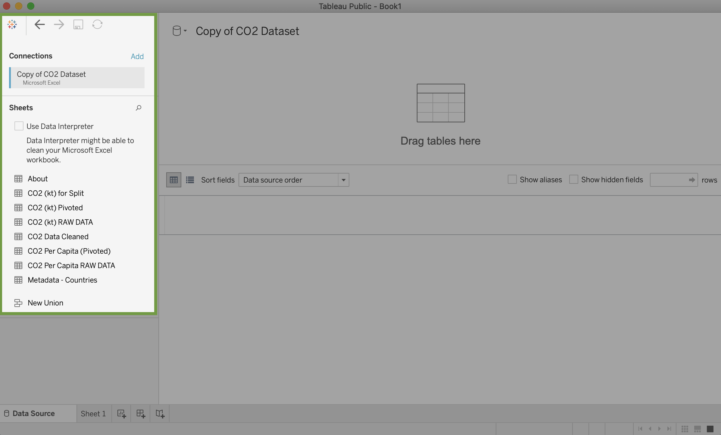

Sheets:

- About

- CO2 (kt) for Split

- CO2 (kt) Pivoted

- CO2 (kt) RAW DATA

- CO2 (kt) Cleaned

- CO2 (kt) Per Capita (Pivoted)

- CO2 (kt) CO2 Per Capita RAW DATA

- Metadata - Countries

6. Double-click on the sheet CO2 Data Cleaned to load that sheet's data into the main part of the screen. You can also drag and drop the sheet into the area where it says Drag tables here.

Once this is done, the main display will appear like this:

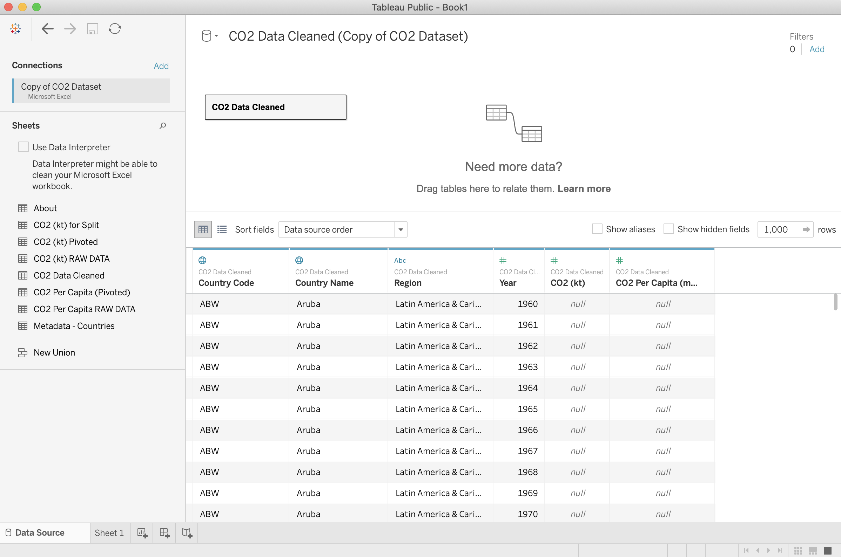

The data in the table are listed in the bottom portion of the display above. By default, Tableau will only show the first 1000 rows in the table, but you can increase the number of rows in the settings above the data view.

Each row corresponds to a single data point, and each column represents a different feature.

Tableau interprets the type of data in each column. The following icons, which are above in the column name, refer to how Tableau interprets the data type in the column:

* #: Numeric data
* Abc: String data
* Globe: Geographic data
* Calendar: Date data
* Calendar with a clock: Date and time data

In the image above, you can see that Tableau has interpreted the first two columns as geographic data, the third column as string data, and the last three columns as numeric data.

## Create a visualization of CO2 emissions



Now that you have all of your data loaded into Tableau, you can use it to make visualizations. Create a visualization in which the CO2 emissions are displayed per country.

To do this, click on the Sheet1 tab in the lower-left of the display.

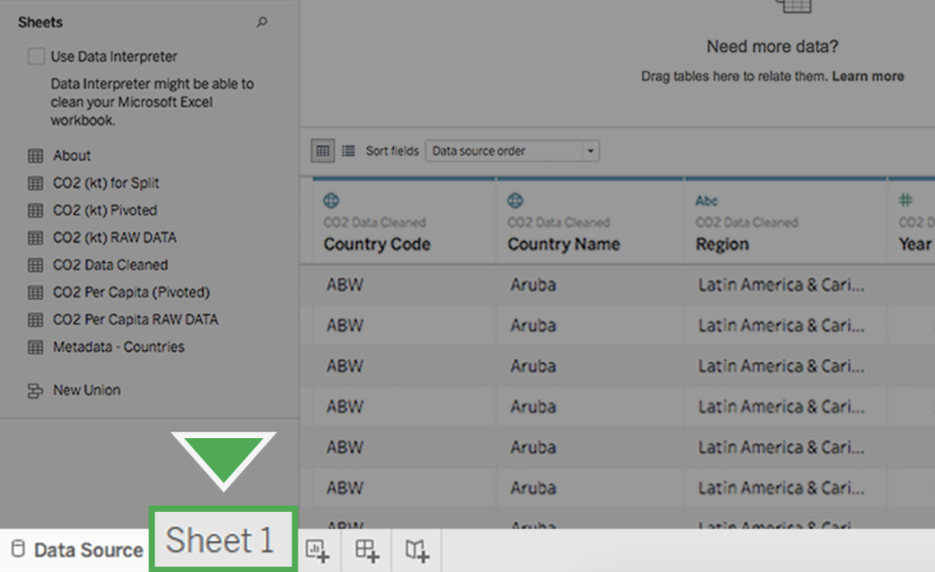

Clicking this tab will change the display to this:

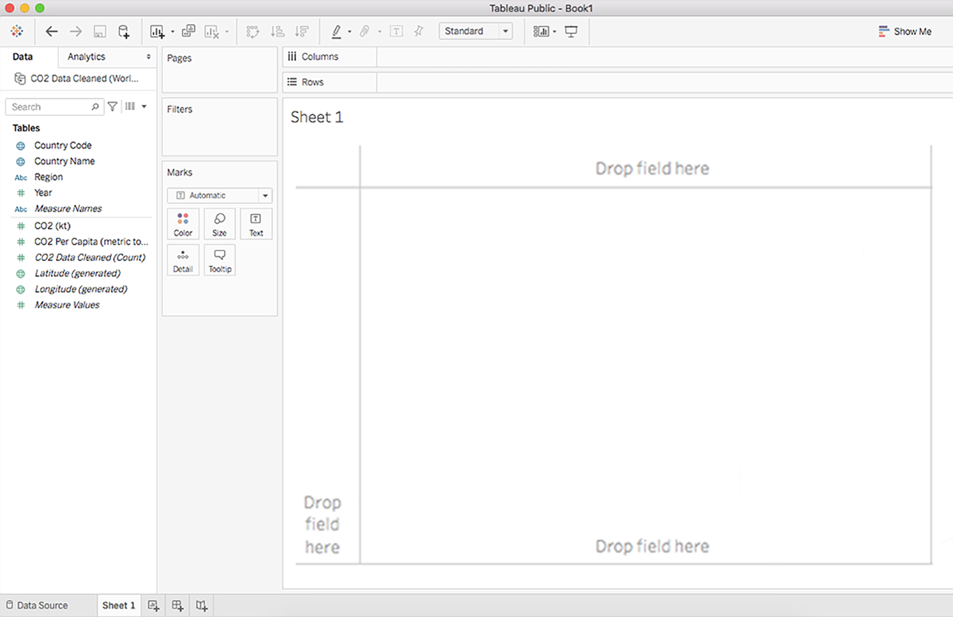

In the middle of the screen, there is a menu indicating "pages", "filters" and "marks". Under marks, there is a choice of color, size, text, detail, and tooltip.

### Use dimensions and measures



On the far left of the screen is a banner with column names above a grey line. In Tableau, these are called the dimensions of the data. Below this line are the different measures that you can track for these dimensions.

Now, create a chart that displays the CO2 emissions per country. Double-click the Country Name dimension. The main display will show a map of the countries on the planet with dots indicating which countries are represented in the data.

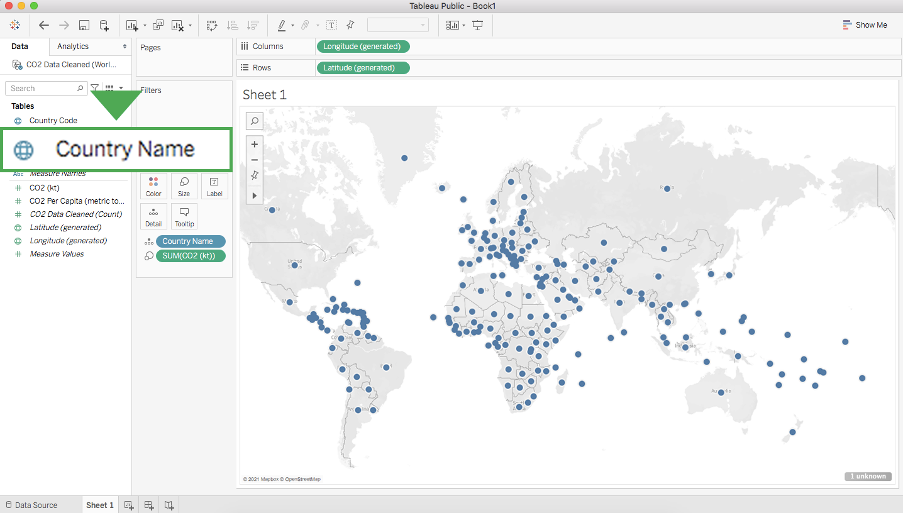

The dots are all the same size because—with no measure selected—Tableau defaults to scale each country equally. If you want to scale by CO2 emissions, you need to include a specific measure.

Double-click (or drag and drop onto the sheet) the measure CO2 (kt). This will change the size of the dots to be proportional to the amount of CO2 emitted like the example below.

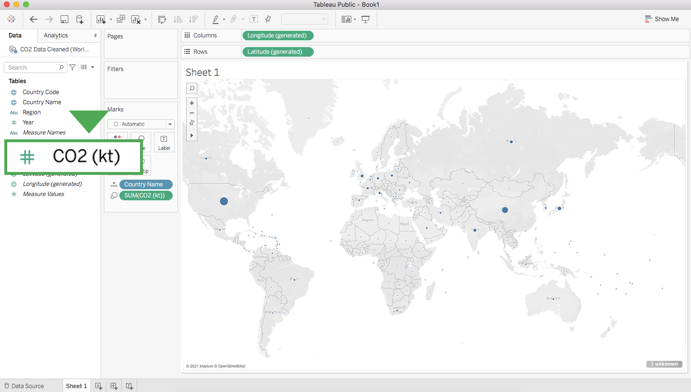

Tableau has a wide selection of options for depicting the measure for a given dimension. Most of these options are contained in the middle column between the main display and the column with dimensions and measures.

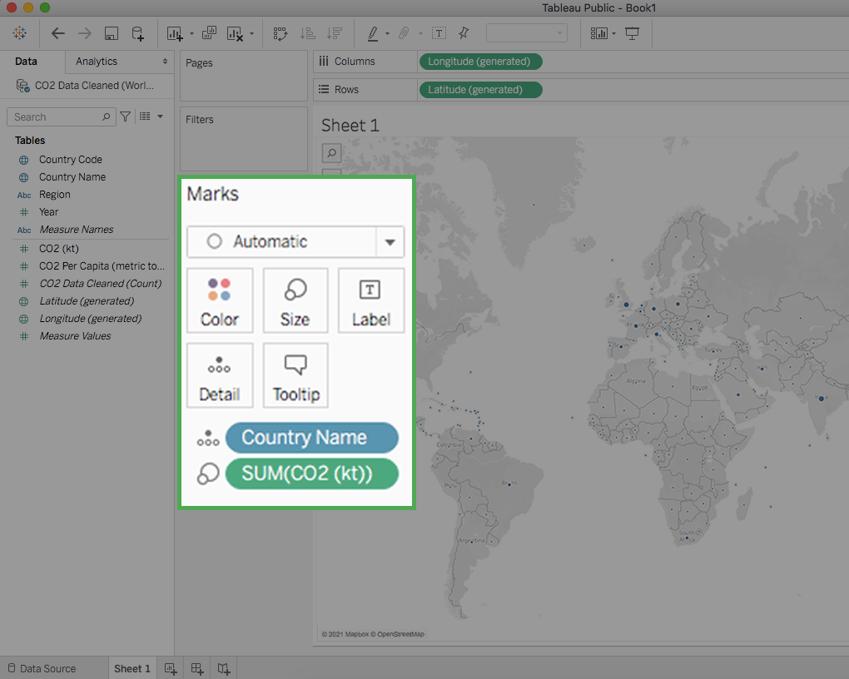

## Customize your chart



If you drag and drop a measure on one of the option classes, such as Color, Size, and Label, you can change that aspect of the measure’s visualization on the chart.

For example, if you want to change the color of the CO2 measure, drag the measure CO2 (kt) to the box with the Color label. Then, click on this box to pull up a list of options for the colors you can use.

Play around with the different options here to learn what you can do. Don't worry about making a mistake. If you ever want to reverse a change you make to a Tableau sheet, you can hit the Back arrow button in the top-left corner of the screen:

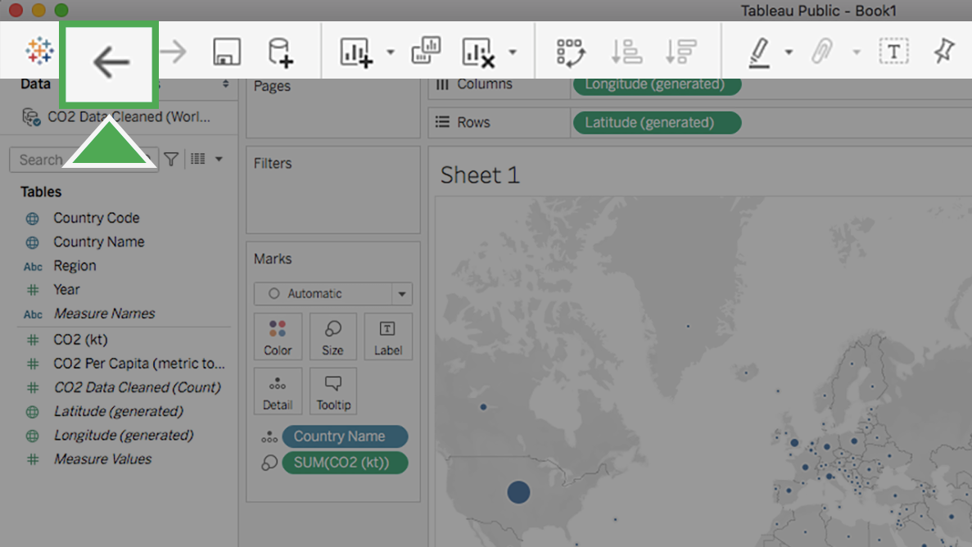

There you go! You just created your first chart using Tableau.

### Change dimensions and measures



Changing either the dimension or the measure on a chart is very easy to do. Suppose that instead of visualizing the CO2 per country, you want to chart the CO2 per capita per region. To do this, double-click on the dimension Region and then do the same for the measure CO2 Per Capita. This will result in a new chart like the example below:

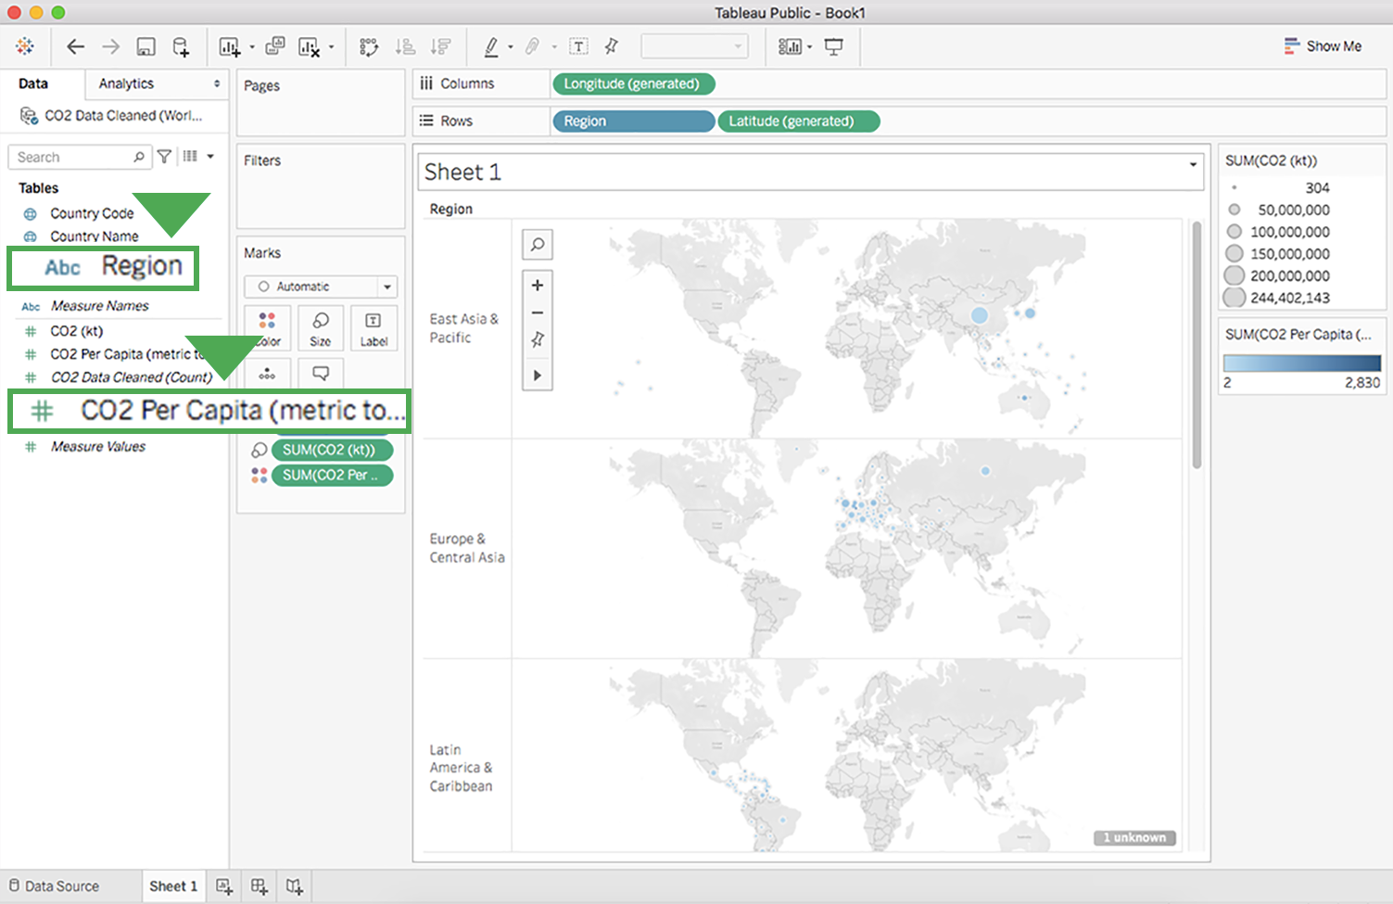

Under "measure names", CO2 Per capita is highlighted.

### Edit the title



Currently, the title of this chart is Sheet 1. To edit the title of the chart:

1. Hover the cursor over the title box. An arrow will show up in the upper-right of the box. If you do not see the arrow on the upper-right of the box, make sure to close any panels on the right of your screen or double-click Sheet 1 to change the title.

2. Click on this arrow to bring up a drop-down menu. Select Edit Title.

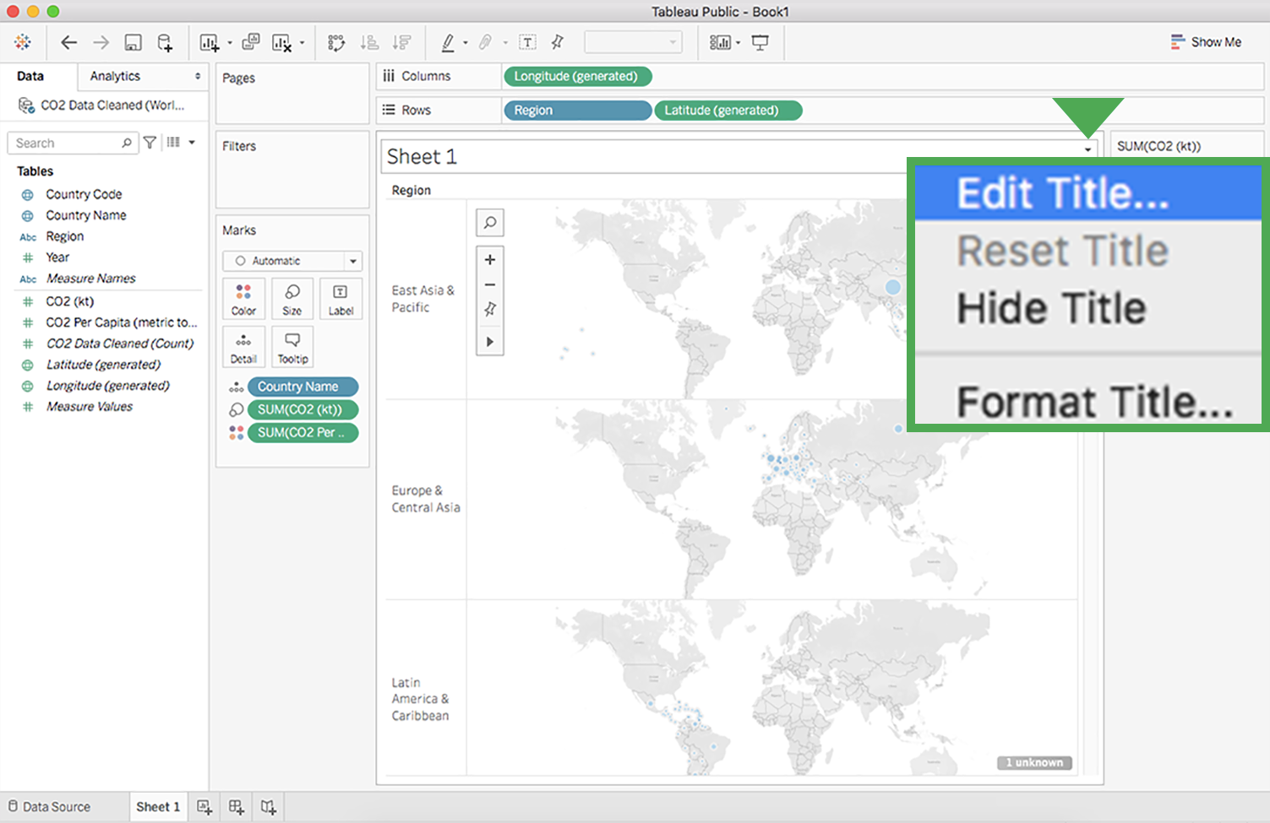

3. Enter any title you wish.

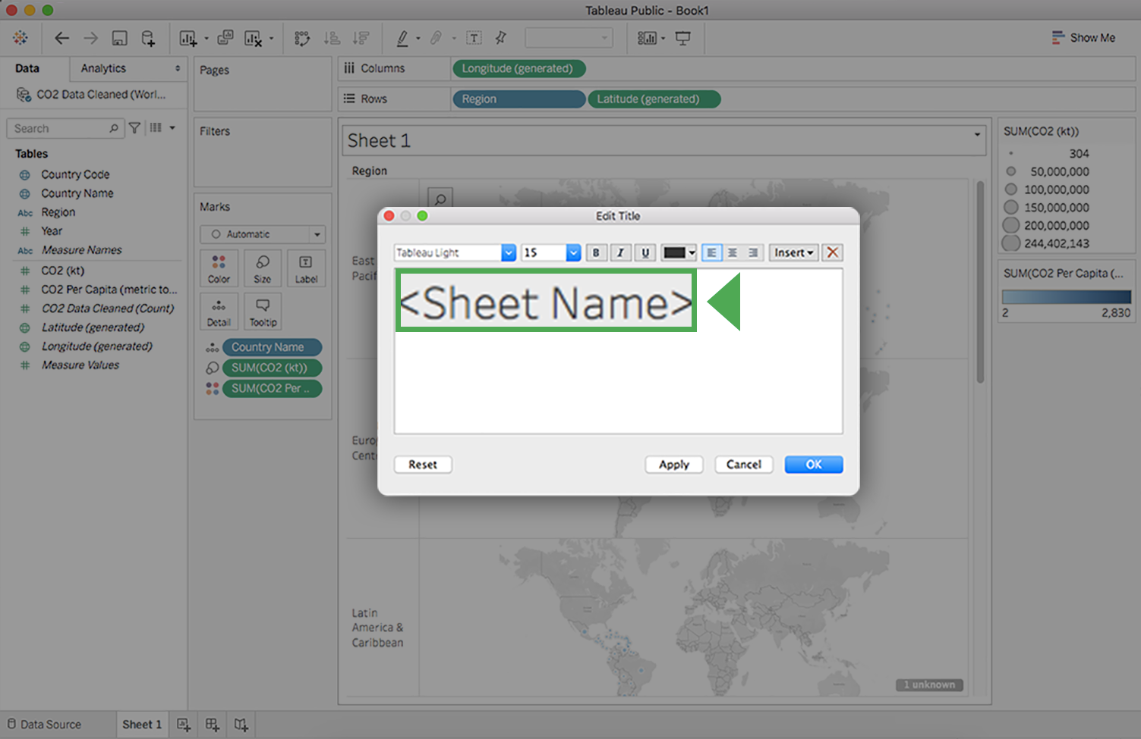

### Delete a chart



If you want to delete a chart from the sheet, select the Clear Sheet button in the toolbar.

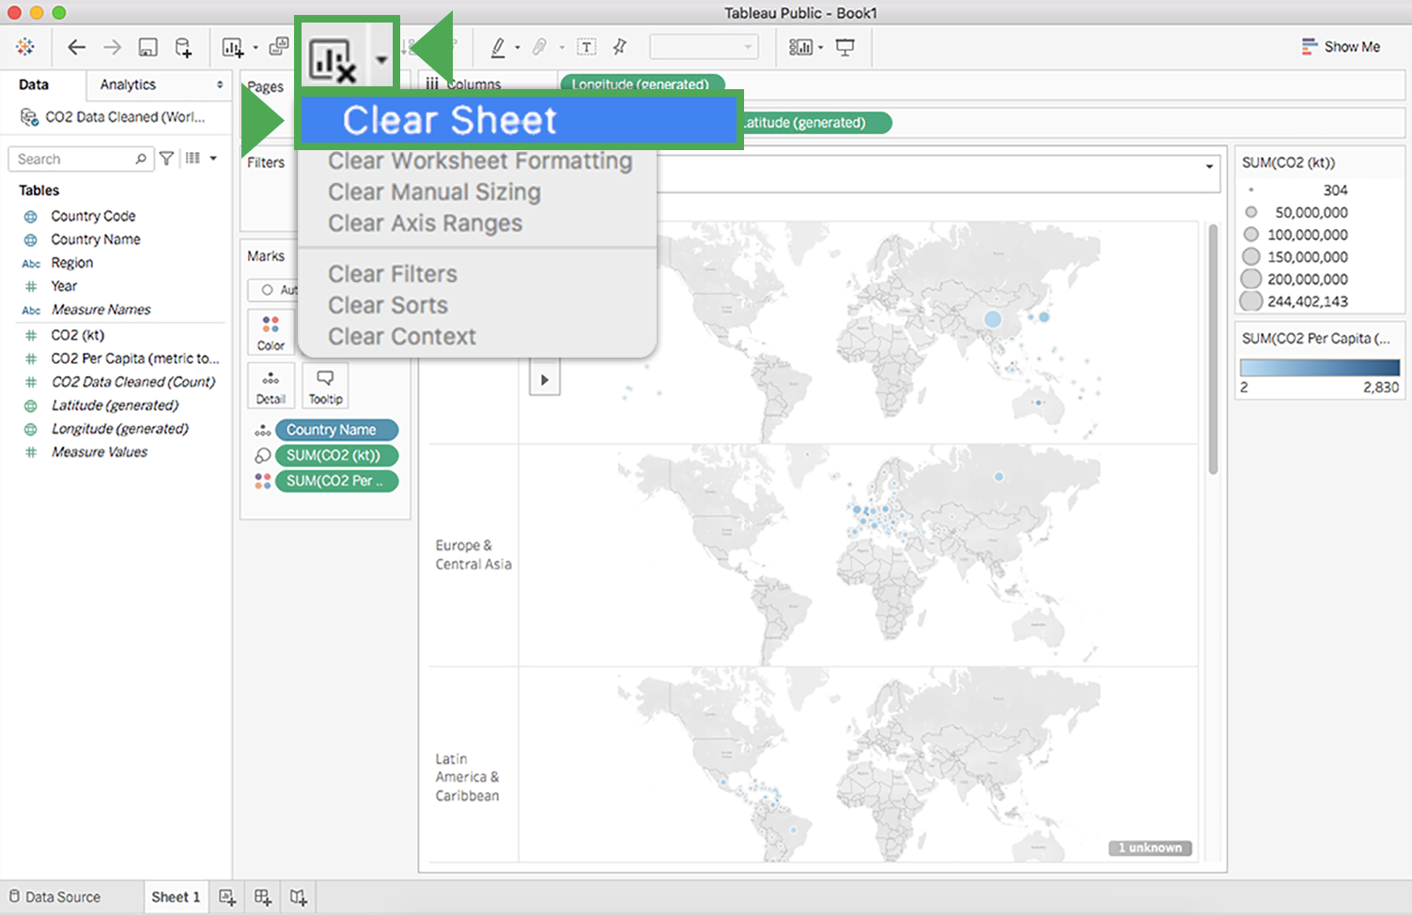

This will completely wipe out the chart and bring you back to an empty sheet. Don't worry if you do this by accident or change your mind. The Back button introduced earlier will bring the chart back.

If you want to delete a sheet in its entirety, all you need to do is right-click on the sheet's tab at the bottom of the screen and select Delete. Note that you will not be able to delete a sheet if it is the only sheet in your file.

Note: Unlike clearing a sheet, deleting a sheet altogether cannot be reversed!

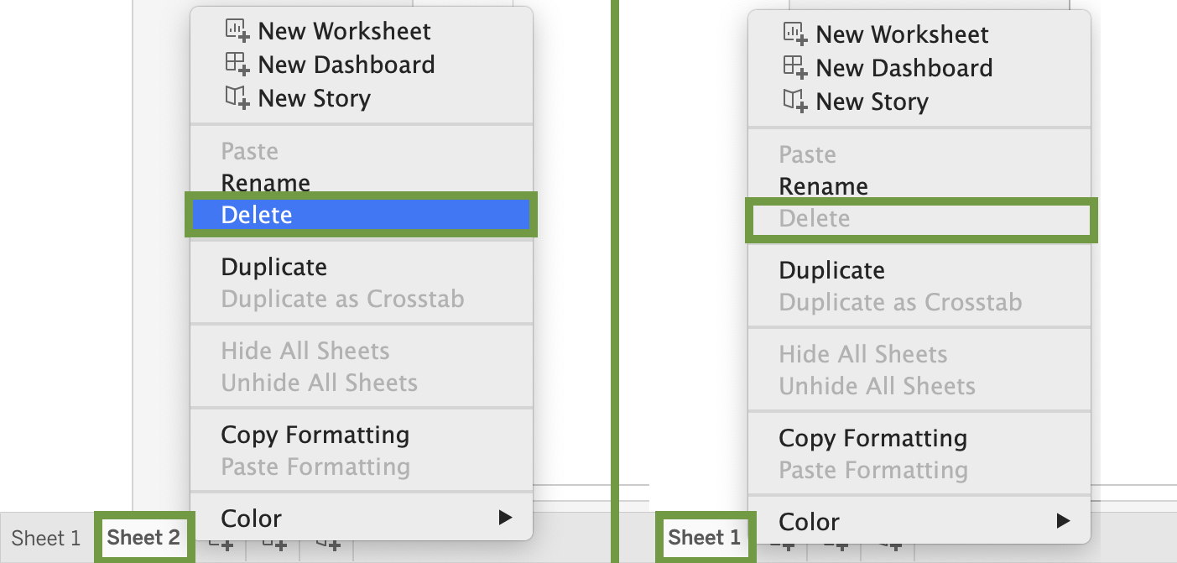

Congratulations! The skills in this hands-on activity are all you need to get started visualizing your data. This is far from the end of the story, though. In follow-up activities, you will review more advanced tools in Tableau. Until then, this is enough to get you started.